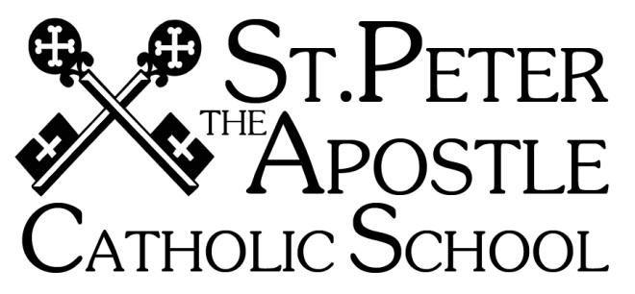

PARENT HANDBOOK

Phone: 760-689-6250
Fax: 760-689-6240
Website: www.spacschool.com

Preschool Direct Line: 760-689-6262

Fr. Ignatius Dibeashi, Pastor/Superintendent
Mrs. Shawna Taitano, Principal
Mrs. Katie Beltran, Vice Principal
Mrs. Gisela Gutierrez, Preschool Director

The principal reserves the right to amend this handbook for just cause. Changes will be published in the weekly newsletter, Peter’s Page.

Look for updated policies

TABLE OF CONTENTS
GENERAL INFORMATION 5
Philosophy 5
Mission Statement 5
Schoolwide Learning Expectations 5
Accreditation 5
Non-Discrimination Policy 5
School Hours 5
Minimum Day Schedule: 5
Office Hours 5
After School Care Program 6
Hot Lunch Program 6
ADMISSIONS 6
Priority of Admittance 6
Kindergarten 6
Returning Students 6
Registration Procedures 6
Special Needs 6
Stewardship 7
Rights and Responsibilities of Students……………………………………………………………………………………………………………………………….. 7
FINANCE POLICIES 7
Tuition 7
Tuition Assistance 8
Non-Payment of Tuition 8
Requests for Reimbursement 8
Returned Checks 8
Parent Volunteer Hours 8
HEALTH/MEDICAL/SAFETY/EMERGENCIES 8
Visitation of Students during School Hours 9
Release of Students during Class Hours 9
Live Scan/CMG Connect/Selection.com Background checks 9
Child Protective Services and Law Enforcement Access 9
Marital/Custodial Arrangements 9
Child Abuse Reporting Procedures 9
Emergency Card 9
Illness and Injury 9
Medical Appointments 10
Medical Conditions 10
Authorization for Treatment 10
Communicable Disease/COVID-19 10
Head lice 10
Immunizations 10
Medications 10
Smoking 10
Animals on Campus 11
Student Confidentiality 11
Student Insurance 11
Emergency / Disaster Procedures 11
CarlineProcedure 11
CURRICULUM 12
Leveled Math Placement 12
Family Life Education 12
Family Presence at Weekly Mass 12
Field Trips 13
Field Trip Drivers 13
Honor Roll 13
CJSF Requirements 13
Jupiter Grades 13
Promotion 13
Retention 13
Report Cards 13
Progress Reports 14
Missing Work Policy (Grades 4-8) 14
Homework Policy 14
Academic Honesty 14
Plagiarism 14
Testing 14
Tutoring 14
Graduation 14
Graduation Parties 15
Minimum Expectations/Academic Probation/Participation In 8th Grade Graduation Activities (Grad Week) 15
Grading Scale/ Performance Rubric 15
Computer Access/ Printing 15
Sacramental Preparation 15
Liturgies and Religious Celebrations 15
Internet/Email/Social Media 15
ATTENDANCE 16
Absence and Tardiness 16
Homework Requests 16
Appointments 17
Family Vacations 17
Arrival/Dismissal/Supervision of Students 17
DISCIPLINE 17
Vandalism 17
Harassment 17
Student to Student Harassment 17
Student Threats 17
Probation, Suspension, Expulsion 18
Suspended Students 18
Abuse ofTeacher………………………………………………………………………………………………………………………………………………………………….19
Assault 19
Transfer on Grounds of Parental Behavior 19
Resolving Issues 19
STUDENTS 20
School Property 20
Skateboards 20
Cell Phones 20
Telephone Use 20
Gum 20
Parties and Invitations 20
COMMUNICATION 20
Access to Student Records 20
Student Transcripts 21
Appointments with Faculty Members 21
Classroom Visits 21
Communication Folder 21
UNIFORMS 21
Personal Appearance of Pupils 21
Free Dress 21
Uniform Policy …………………………………………………………………………………………………………….21-23
PRESCHOOLHANDBOOK…………………………………………………………………………………………………………………………………………………….24-27
IMPORTANT POLICIES WITH SIGNATURES ………………………………………………………………………………………………………………………… 27-29

GENERAL INFORMATION
Philosophy
St. Peter the Apostle Catholic School is an integral ministry of our Parish. Catholic values are interwoven into a comprehensive curriculum relevant to the Gospel. Recognizing and encouraging parents as the primary educators and teachers as facilitators, students are empowered to take responsibility for their learning and challenged to reach their individual potential. St. Peter the Apostle Catholic School teaches Traditional Values, Today’s Technology, and Tomorrow’s Leaders!

Mission Statement
St. Peter the Apostle Catholic School is dedicated to academic excellence and devoted to nurturing courageous leaders rooted in prayer, community, and service.

Schoolwide Learning Expectations
St. Peter the Apostle Catholic School students are called to LEAD by being . . .
LIFE-LONG LEARNERS
EMPOWERED
ARTICULATE
DISCIPLES
Vacare Deo ~ Open to God

Accreditation
St. Peter the Apostle Catholic School participates in the accreditation process formulated by the Western Catholic Educational Association (WCEA) and the Western Association of Schools and Colleges (WASC). Participation in this process assures continued school improvement through on-going self-study and evaluation. The school completed its last self-study in 2026 and was granted the highest accreditation for the full six-year period. The next accreditation will be in Spring 2032.

Non-Discrimination Policy
St. Peter the Apostle Catholic School admits students of any race, color, national and ethnic origin to all the rights, privileges, programs, and activities generally accorded or made available to students at the school. The school does not discriminate on the basis of race, color, racial or ethnic origin, in its administration of its educational and admissions policies, athletics or other school administered programs.

School/Preschool Hours -
7:30am-7:50am Student will go directly to classroom – NO PLAYGROUND TIME
7:50am Monday and Wednesday Morning Assembly /Pray and Pledge
8:00am Instruction begins. Students are late at 8:00am and will be written as tardy.
9:20-9:35 Recess for K-2
10:00-10:10 Recess for 3-8
11:20-12:00pm Lunch K-2 (eat first/play)
12:00-12:40 Lunch 3-5 (eat first/play)
12:20-1:00 Lunch 6-8 (play first/eat)
3:00pm Dismissal
3:15 Aftercare begins
5:00pm Aftercare closes/Preschool Closes

Minimum Day Schedule:
Minimum days are every Friday and some designated days throughout the year. Minimum day schedule is observed for grades K-8. Dismissal is at 12:00 Noon. Preschool maintains a regular schedule, unless otherwise noted. These days allow for faculty professional development and meetings. Reminders can be found in the monthly calendar, school website, and weekly newsletter.

Office Hours
The school office is open from 7:30am-4:00pm on all school days.

After School Care Program
The After-School Care Program supports working parents by providing planned, safe, and caring supervision beyond the regular school day. Any child in K-8 who is enrolled in St. Peter the Apostle Catholic School is eligible for the After School Care Program, which operates from 3:15 -5:00 on all regular school days and 12:15 to 5:00 on minimum days. Parents are billed on a monthly basis through FACTS. Billing begins promptly after the carline.
Regular Day 3:30-5:00 pm $7.00 per hour/per child
Minimum Day 12:30-5:00 pm $7.00 per hour/per child
Late Fee (K-8) After 5:00pm $2.00 per minute

Hot Lunch Program
Thanks to the efforts of our lunch parents we are able to offer a hot lunch every day. The menu for the upcoming month is sent home in the Communication Folder, usually the second week of the month, and needs to be returned, with payment, by the due date. You can choose the days for hot lunch or bring your own lunch.

ADMISSIONS
No person shall be admitted as a student in any Catholic school unless that person and his/her parents or guardians subscribe to the school's philosophy and agree to abide by the educational policies and regulations of the school. It is important to remember that St. Peter the Apostle Catholic School cannot accommodate the needs of students who demonstrate severe grade level, emotional, or behavioral deficiencies. Recommendations can be made for specialized testing for academic deficiencies caused by specific learning disabilities. Referrals for alternative school placement are also available. The principal makes the final determination regarding acceptance.

Priority of Admittance
Applications for new enrollment have priority according to the following order:
- Re-enrollments from previous year (including St. Peter the Apostle Catholic Preschool students)
- Siblings of currently enrolled students
- Children of St. Peter the Apostle Catholic Parish
- Children from other Catholic parishes
- Children of non-Catholics

Kindergarten Requirements
- Be 5 years old by September 1st of the academic year and/or developmentally ready as determined by the teacher and principal using an approved screening process.

Returning Students
Returning students will be admitted to school provided all tuition and fees from the previous year have been paid.

Registration Procedures
The following are required for registration and must be provided to the school within 14-days or the child will not be permitted in class:
- Birth Certificate
- Baptismal /First Communion Certificates (if applicable)
- Student’s last report card
- Updated immunization records
- Non-refundable registration fee for each student

Registration Fee
Full registration fee is due upon turning in the registration packet. The school will no longer accept partial payment of the registration fee.

First Month’s Tuition
The school will collect 50 percent of the first month's tuition on July 5th. This will be no refundable should you make the decision to withdraw your child from St Peter the Apostle Catholic School.

New Student Evaluation Period
Students will be assessed and observed during a 14-day probationary period to ensure proper placement and learning environment for the child. This will permit sufficient time to ensure that the child will be successful at our school. A parent meeting will be set-up to finalize placement at St. Peter the Apostle Catholic School or discuss alternative school placement.

Special Needs
St. Peter school through its general education program and Learning Support Program, strives to serve the needs of diverse learners using appropriate interventions, accommodations, and modifications. St Peter’s is committed to meeting the needs of all students insofar as possible. There are some conditions, however, for which the school cannot provide the necessary resources. If the student is evaluated through the Public Unified School District or privately and if St. Peter’s cannot offer the recommendations, parents are responsible for providing the recommended services for the students welfare. In cases where St. Peter’s cannot adequately meet a student's needs, a referral will be made for alternative school placement. The administration makes the final determination regarding admission and proper placement of students.

Stewardship
St. Peter the Apostle Catholic Parish holds that giving of your time, talent, and treasure are examples of your Faith in which you as a parent fully participate and support the life of the church and the true values of Catholic education.
      - Regular family attendance at Sunday Mass
- Involvement in school and Parish activities/events
- Role modeling to your children the act of giving your time, talent, and treasure
- Regular, consistent giving to your parish/ other Catholic charities (goal: 10% of your annual gross income)

Rights and Responsibilities of Students
I have the right and responsibility to learn in a Catholic atmosphere.
- I am responsible for my own learning, and I allow others to learn.
- I will do my best always.
- I will come to class prepared with necessary books and materials.
- I will do my homework.
- I will arrive on time for school.
- I will be respectful during prayer, liturgy, religious celebrations, and school activities.
- I will bring home all school information for my parents.

I have the right to be respected and to be treated with dignity and the responsibility to treat others in a similar manner.
- I will treat everyone kindly and with respect.
- I will speak to others in an appropriate and polite manner.
- I will listen respectfully when others speak.
- I will respect other people’s space and belongings.
- I will work so that other students can work.

I have the right to be safe and the responsibility to permit others to feel safe.
- I will obey all school and classroom rules.
- I will avoid games that promote violence or that could hurt others.
- I will not bully or tease others.
- I will report any bullying or teasing to a supervising adult.
- I will tell an adult if someone is hurt or doing something dangerous.
- I will listen to the playground supervisor.
- I will use school equipment in a safe and respectful manner.
- I will play safely on the playground equipment and only when it is my turn.

I have the right to learn in a clean environment and the responsibility to do my part in helping to keep our school environment clean.
- I will keep my desk and classroom neat and tidy.
- I will clean up after myself after recess snack and lunch.
- I will keep the restroom clean.
- I will throw litter in the trash.
- I will cooperate in keeping our school yard clean.
- I will recycle as much as possible.

As a member of my Catholic school community, I pledge to: Resolve problems in a peaceful way. Set an example by being a caring and compassionate person. Use kind words, and not to tease others. Never let my words or actions hurt others. Always be part of the solution and encourage others to do the same.

FINANCE POLICIES

Tuition
Every parent of a student in St. Peter the Apostle Catholic School signs a written agreement to pay a specified tuition and fees amount. Monthly payments are made for the convenience of families and are not to be interpreted as payment for a particular month. As part of the tuition agreement parents agree to comply with all school policies and regulations. Four options are available for the payment of tuition:
- Annual Payment
- Semi-Annual Payments
- 10/11/12 Monthly Payments

Automatic monthly deductions from your checking/savings account through the F.A.C.T.S. Tuition Management Company Enrollment is required for Semi-Annual and Monthly payments. There is a $50 annual fee to enroll with F.A.C.T.S.

FACTS Billing Updated Policy – all unpaid past due balances and after-care charges will be charged through FACTS and automatically deducted from your bank account either on the 5th or the 20th. The date will depend on what date you set up for your tuition payment.

Refund Policy
50 percent of first months Tuition, Registration, Technology, Materials Fee, and Diocesan Service fees are non-refundable. Tuition is refundable, based on the number of unused months of prepaid tuition. Attendance for one day in the month constitutes payment due for the month.

Scholarship or Discounted Tuition
Scholarships are very limited and St Peter the Apostle Catholic School is only able to assist families for one year based on financial needs. An application will need to be completed as well as a letter indicating how you will give of your time and talent in order to be eligible for scholarship.

Discounted tuition is available for one year and will not exceed twenty percent of the annual tuition rate. A letter indicating how you will give of your time and talent in order to be eligible for discounted tuition.

In order to receive a scholarship or discounted tuition , you are held accountable to:
- Regularly attend Saturday/Sunday Mass. You are the primary role model to your children.
- Your child must maintain at least a C average.
- Volunteer at school—lunch help, office help, Scrip help, teacher help, etc.

Non-Payment of Tuition
Parents experiencing a temporary financial situation should contact the principal immediately to make alternative financial arrangements. Every effort will be made to assist the family in need. All current year tuition/fees must be paid to register for the new school year. Chronic or ongoing delinquencies may result in:
- Withholding student report card/diploma
- Delinquent accounts forwarded to a collection agency
- Your child is not allowed in the classroom until payment arrangements are made with the principal.
In the event of a transferring student, notification will be sent to the next Catholic school of non-payment of tuition/fees, which may result in denial of enrollment.

Requests for Reimbursement
Prior to making any purchases for the school or events the Principal must approve all expenses. Any and all requests for reimbursement for expenditures, refunds, etc. must be made in writing within and provide receipts within 30 days.
Requests for Donations
All requests for donations from local businesses or our school families must have prior approval from the principal. Individual groups may not solicit for donations of goods or money without this approval.

Returned Checks
- There is a $35.00 returned check charge for the 1st check returned for non-payment.
- This fee will increase to $50.00 for each additional returned check.

Parent Volunteer Hours
We rely on parent volunteers for fundraising events and different opportunities around campus. Parents that receive scholarship assistance or discounted tuition MUST give back to the school by volunteering. Please let us know in advance what you can help out with in order to continue receiving financial support. Families that do not volunteer are in jeopardy of losing their scholarship or discount.

Fundraising Participation
Tuition does not fully cover the costs of educating each child. To defray the additional costs, we rely on parent participation in all fundraising. Active involvement in the life of the school and parish is expected of all parents. Each family is asked to participate in all fundraising events. There are designated mandatory participation events. Parents will be charged the mandated rate for non-participation. You can “buy-out” of fundraising by submitting a $1000.00 payment by September 30th for the academic year.

HEALTH/MEDICAL/SAFETY/EMERGENCIES

Visitation of Students during School Hours
All persons entering the school, including those assisting in the classroom, are required to check in at the school office. Parents who wish to observe classroom procedures must obtain permission from the principal. The school may not be used by non-legal guardians for the exercise of visitation rights. Persons, agencies, or organizations desiring to contact individual students during the school day must seek permission from the principal.

Release of Students during Class Hours
No student is permitted to leave the school grounds at any time during school hours or to be released from class without parent permission. Students who leave early must be accompanied out by a parent or authorized person at the school office. If your child will be signed out by anyone else, please notify the office in advance. Students leaving early (even if it’s only 15 minutes) are marked ½ day absent.

Live Scan/CMG Connect/Selection.com Background checks
All St. Peter the Apostle Catholic School personnel and volunteers, to include field trip drivers and chaperones, must complete the Live Scan/CMG Connect/Selection.com Background checks.

Child Protective Services and Law Enforcement Access
Whenever a representative of a Child Protective Agency deems necessary, a suspected victim (student) of child abuse may be interviewed during school hours, on school premises, concerning a report of the suspected child abuse that occurred.

Marital/Custodial Arrangements
Parents must notify the school of any changes in marital or custodial arrangements. Divorced or separated parents must file a court-certified copy of the custody section of the divorce or separation decree with the principal’s office. The school will work to honor the agreement but cannot be held responsible for parents not following the court order.
Child Abuse Reporting Procedures
In accordance with California law school faculty members are obligated, under penalty of fine and jail term, to report the reasonable suspicion of physical abuse, emotional abuse, emotional deprivation, physical neglect, inadequate supervision, or sexual abuse and exploitation. In this very serious and narrow legal area, the school will not contact parents or legal guardians in advance of making a report to legal authorities, which would be the procedure followed in most other legal matters.

Emergency Card
All students must have an emergency card on file, with the School Office, listing medical conditions and the names of two people who may be contacted in the event neither parent can be reached in an emergency or illness. Emergency cards must be submitted within 4 school days of beginning the school year. Students who have not submitted the completed cards will not be admitted to class on the 5th day.

Illness and Injury
Parents are notified when a student is ill or has an injury which requires medical attention. If a parent cannot be reached, an adult listed on the emergency card is contacted. Students are signed out through the School Office.

HEALTH
Our goal is to maintain a healthy environment for the children and staff. Children who are sick will not be allowed to remain at school and must be picked up within 1 hour of calling home. If the school sends home a student that is sick, the student will need to stay home for a minimum of 72 hours to ensure that they are healthy. If you notice that your child is sick, please do not send them to school and keep them home until they are symptom free for at least 24 hours. If you send your child to school sick, this is detrimental to our staff and other students. We need to have everyone healthy so we can stay open. We may need to ask you to keep your child at home for the remainder of the school year if they persistently come to school sick. The following criteria will be used as guidelines for sending a student home.
- A temperature of 100 ⃘ degrees, after being taken once and thirty minutes later with no change downward.
Students should remain home until 24 hours without the use of fever reducing medications (Motrin, Tylenol).
If your child had a fever overnight or in the morning, please DO NOT give him/her Tylenol/Motrin and then SEND THEM TO SCHOOL! If he/she has had a fever prior to the start of school, please keep him/her home to prevent the spread of germs.
- A cold accompanied by sneezing, runny nose, coughing, congestion or Gastrointestinal Infection
- Once you have been contacted to come and pick-up your child, you must pick them up with-in an hour or you will be assessed a $50 fee.

Medical Appointments
Parents need to email the teacher when a student has a medical/dental appointment, indicating the date/time of the appointment. The child will be notified in the classroom when the parent comes to pick up the child. Parents are urged to schedule appointments during non-school hours.

Medical Conditions
Students with diagnosed medical conditions (allergies, asthma, diabetes, etc.) must have that information clearly defined on the emergency card with instructions in case of an emergency. The Authorization for Medication Administration form must be completed. St. Peter the Apostle Catholic School is committed to meeting the needs of all students, in so far as possible. There are some conditions, however, for which the school cannot provide the necessary resources.

Authorization for Treatment
If parents cannot be reached and the illness or injury is serious enough to require medical attention, the principal will review the emergency card and will arrange for treatment. It is understood that enrollment at St. Peter the Apostle Catholic School confers upon the school the obligation to select and provide emergency care when the school is unable to reach the parent(s) and/or designated guardian.

Communicable Disease
Students with communicable diseases may not be in school. Students will be re-admitted into school when the principal and teacher are presented with a signed note from a doctor indicating that the student’s illness is no longer infectious. Parents are required to notify the school office when their child has a communicable disease such as chicken pox, measles, mumps, streptococcal infections, strep throat, lice, scarlet fever or whooping cough. Other illnesses which need to be reported are conjunctivitis (pink eye), impetigo, ringworm, hepatitis, pinworms, and mononucleosis. c

Head lice
Head lice infestation is spread most by close person-to-person contact, sharing clothing (hats, scarves, coats, sports uniforms) or articles (hair ribbons, barrettes, combs, brushes, towels, stuffed animals) recently worn or used by an infected person, or even lying on a bed, couch, pillow, or carpet that has recently been in contact with an infected person. Dogs, cats, and other pets do not play a role in the transmission of human lice. Personal hygiene or cleanliness in the home or school has nothing to do with getting head lice.

Children diagnosed with live head lice can be treated and return to class after appropriate treatment has begun. Successful treatment should kill crawling lice.

Immunizations
St. Peter the Apostle Catholic School follows the required immunization policy of the Federal and State government. There are 10 mandatory vaccines that all public and private schools must follow in order to have in-person learning. No student may be admitted unless he/she has complied with California immunization and health screening requirements. Up-to-date immunization records must be presented to the school office prior to the student entering school. All transfer students are required to submit a copy of their up-to-date immunization record before admission.

Medications
Medications shall not be furnished to students by the school. School personnel cannot administer any medication without the express written permission of the parent/guardian, stating the student’s name, name of the medication and dosage. If a student must have medication during the school day, the following procedure is to be followed:
- A release from the doctor or parent stating the nature of the medication.
- Prescription medication must be in the original container and have the affixed label including the student's name.
- Non-prescription medication must also be in the original container.
- A Completed Medication Release Form must accompany each medication and will be kept in the student's file.
- A new Medication Form needs to be signed for each new prescription.
- All medications will be kept in the School Office. No medication may be kept in the classrooms, student lockers, or book bags. This includes over-the-counter medications, cough drops, vitamins, etc.

Smoking
Schools are smoke-free environments. Possession or use of tobacco or e-cigarettes by students is strictly prohibited and constitutes grounds for probation, suspension, or expulsion.

Animals on Campus
For the safety of all of the students, faculty, and staff, animals are not allowed on campus, even if on a leash. Many students are afraid or allergic to animals.

Student Confidentiality
Teachers will keep confidential information entrusted to them as long as no life, health, or safety is at risk. Parents will be notified of teacher concerns.

Student Insurance
A student insurance program is provided for all students. This program assists in the medical expenses incurred due to accidental injury sustained by children while attending school, while traveling to or from school, or while participating in a solely school sponsored and supervised activity. In the event of an accident, parents will be notified. Claim forms are available in the office.

Emergency / Disaster Procedures
In case of an earthquake, fire, or natural disaster, the school will usually follow the same procedures as Fallbrook Unified School District. The safety of students is first and foremost our priority. As information becomes available, it will be communicated to the parents using the ONE CALL system or general email with instructions and any other safety information.

Students will not be dismissed from school unless a parent or designated individual comes for them. PLEASE KEEP YOUR CHILD’S EMERGENCY CARD UP TO DATE by informing the school whenever there is a change in address, phone number or designated caregiver. All parents or designated individuals who come for students must sign them out at the designated student release station. Please do not telephone the school. Lines must be kept open for emergency calls and communications with local emergency preparedness teams.

Carline Procedures
Please stay in your car and move around the circle before stopping to drop off your child. We move all the cars around and then start loading and unloading. This helps us to get cars off Stage Coach as quickly as possible. We will help get your child out of the car. It is important to the safety of the children and staff that you follow the direction of the adults on duty. It is highly recommended that all parents come through the carline and do not park in the parking lot.

Pick-up Procedure You will enter down by St. Andrew in the lower parking lot behind the Parish Hall. You will drive up and get in line at the stop sign behind the church. We will be able to send in approximately 12 cars at a time to pick up your children and then exit as normal. We will continue this cycle until all the students are picked up. While the system may take us a couple of days to get used to, we will be able to get through the carline in less than 15 minutes if everyone follows the process. If you want to park and pick up your child, you will need to park down by Father Arturo’s house or wait until we open the parking lot at 3:20. Please see the attached map to help you with our Pick-up Line. Please do not ask for your children to walk out and meet you somewhere else. If your children do walk home, you will need to send in a signed letter stating that you wish for them to be allowed to walk off campus. This is a privilege for 7th and 8th Grade students only.
The families that have the Front of Line passes will continue to use the gate code and system already in place. The family that has purchased 1 of the 4 Reserved Parking Spot may continue to use that spot as normal.
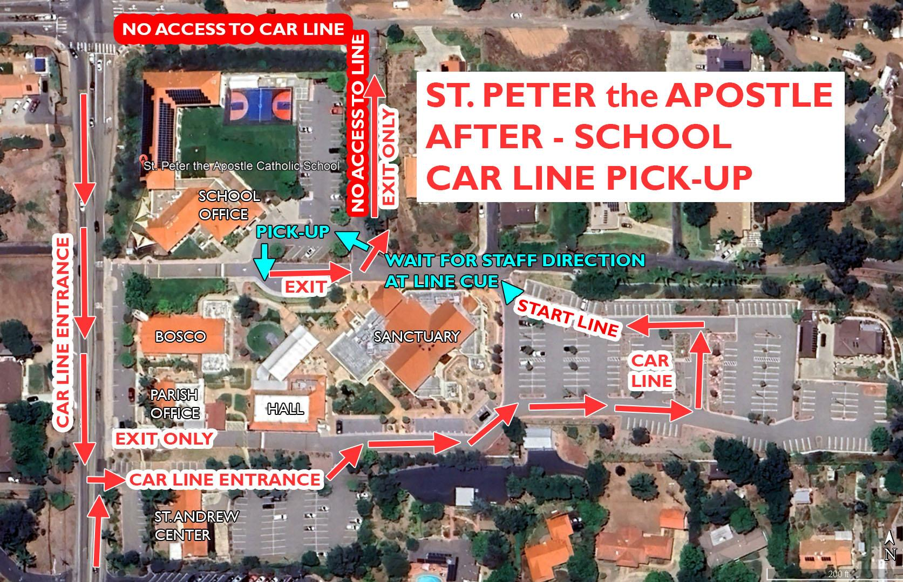
Students are NOT allowed to walk to another area of the campus to be picked up (parking lot, Bosco, etc.). If you want to park and come to the front gate and wait for them, that is fine, but you must walk with your child. If you want to help your children out of the car or watch them go through the front gate, you MUST park. Please know we are working diligently to get your kids out to you quickly and safely!

Preschool Parents: Please do not park in our carline or leave other children in the car while you drop off. Only Preschool parents who are required to sign out their children and those parents with business to take care of in the office should park in the school parking lot. Please do not park in the reserved spots or handicapped spots—even for just a minute! Please do not park or leave your car unattended in the carline.

CURRICULUM

Leveled Math Placement
To support high achievement of all students and ensure that all students are given the appropriate opportunity to make acceptable and measurable progress toward clearly defined Schoolwide Learning Expectations and challenging, comprehensive, and relevant curriculum standards, a Leveled Math Placement Program is available to students in grades 1 -8. Students will be appropriately placed in a math class that helps them grow and meet the curriculum according to their needs. The criteria for placement in a math course are based on four performance expectations:
- Teacher recommendation
- Placement Readiness Test
- STAR scores
- Report card math grade
Assessments will be completed for each student towards the end of a school year, for placement in the upcoming school year. If a parent wishes his/her child to skip a math level, the student must first earn a 90% on the Placement Readiness Test and an 80% for the advanced course. Placement in an advanced math level is only offered to students who will excel at that level.

Family Life Education
The subject matter of the Family Life curriculum follows Catholic Church teachings and is integrated into the study of Religion, Social Studies, and Science, when appropriate. Parents are encouraged to review the Family Life textbooks at Back-to-School Night and to present this information to their child at home. Each child should receive this education both at home and at school, so that the child views his/her sexuality as a gift from God.

Family Presence at Weekly Mass
As a Catholic school, we recognize that there is no greater opportunity for parent-directed religious education than the presence at Sunday Mass. As a Parish School, it is understood that weekly Mass attendance provides tremendous opportunity for community building in a Christ-centered environment. It is essential to our mission as Catholic educators, that families attend Sunday Mass on a weekly basis.

Field Trips
Field trips are planned by the teacher and financially supported by the parents. Students can be denied participation if they fail to meet behavioral requirements. Every field trip has specific educational goals related to the curriculum. No student shall be allowed to participate in any field trip without express written permission from the parent/guardian, utilizing the specified field trip permission form. A separate permission slip must be obtained for every trip. Telephone calls will not be accepted in lieu of the proper forms.

Field Trip Drivers
All drivers/chaperones must complete the CMG Connect safe environment and background check process. You will need to complete both one week prior to the field trip to ensure that you are cleared prior to driving on a field trip. All drivers must submit a copy of a valid California driver’s license and proof of insurance for each field trip. Parents who drive and/or supervise may not bring other siblings. Parents cannot attend a field trip that does not drive due to limited admission. Please check with the teacher first before making plans to attend a field trip. Unless you confirm with the teacher that you are driving on a field trip, you may not attend, you may not attend.

Honor Roll
The purpose of Honor Roll is to provide recognition for academic achievements. Honor Roll will be given at the end of each trimester.Grade 8 students are eligible to receive High Honors recognition at 8th Awards/Graduation for maintaining Honor Roll status for three consecutive trimesters or more during the 8th grade year.

- Criteria
  - Students in grades 6-8 are eligible to receive academic honors based upon their overall academic grade percentage and will be awarded in 3 different categories
  - An "A" or "B" (possibly a C) is required in each graded subject
  - Students will fill out a form and average their grades
  - No student can earn a C in behavior and earn Honor Roll
  - No student can earn an D or F and make Honor Roll Students in Grade 5 are eligible to receive in Trimester 3
- Awards
  - Principal’s List - Students who earn 97% - 100%
  - High Honors - Students who earn a 90% - 96%
  - Honors - Students who earn an 82%- 89%

CJSF Requirements
CJSF is a statewide organization founded for the purpose of fostering high standards of scholarship, service, and citizenship in the middle grades. 7th and 8th grade students earn points based on their grades. Seventh graders will be eligible starting 2nd trimester based on 1st trimester grades. An "A"=3pts; "B"=1 pt.; and "C"=0 pts. Students must earn 14 points per trimester. Qualifying courses are Religion, Math, Science, Language Arts,Reading/Literature, and Social Studies. Students who have a D/F in any subject will not qualify for membership for that trimester.

In order to earn the Gold Honor Cord for graduation, students of chapters at trimester schools must be a member for 2 trimesters based on 7th grade grades and 2 trimesters based on 8th grade grades. As with semester schools, the 3rd trimester grades may be used if needed to qualify. A common misunderstanding is that it is a total of 4 trimesters: it is not 3 of one year and 1 of another. It must be based on 2 trimesters of qualifying from both 7th and 8th grades.

Students in grades 6 to 8 are required to complete 10 hours of volunteer service per trimester. Tutoring, coaching, volunteer work can all be counted. The goal is for members to balance their high academic achievement with public or school service.

FACTS Family Portal
The FACTS Family Portal is designed to give families convenient access to school-related information, including grades, attendance, schedules, and progress reports. It also allows parents to manage tuition payments, lunch orders, and other financial matters. The portal is accessible online, and families can log in at any time to view available information, with additional tabs and features becoming visible as the school year progresses and data is updated.

Promotion
Only those students who satisfactorily complete the work of a particular grade shall be promoted to the next grade. Credit for courses shall not be given solely on the basis of "seat time". Students who withdraw before the end of the trimester or school year, will be given an “incomplete”.

Retention
In case of slow progress, each student will be considered individually. Any decision concerning non-promotion must be made after considering all facts related to the student's development (emotional, physical, social, intellectual, and academic). It is at the discretion of the principal, whether the school can continue to meet the educational needs of the individual student.

Report Cards
Report Cards are issued three times a year. Any requests for grade reconsiderations or recalculations must be made in writing to the principal within one week of the receipt of the grade.

Progress Reports
A Progress Report for all students will be sent home in the Communication Folder at mid-trimester. Parents are reminded that the Progress Report is not a report card, but rather an indication of progress to date in a specific area.

Missing Work Policy (Grades 4-8)
All late work will be recorded for a maximum of 70% (C-). The teacher will notify parents of missing work in order for us to work together on a plan to make up for missed work. If work is missing more than 2 weeks, the assignment will be recorded as a zero and will no longer be able to receive credit. A student that is missing more than 3 assignments, will be asked to sit out of PE until all work is made up.

Students who are absent or tardy are responsible for any work missed. It is the students responsibility to collect and work on work missed during their absence. Students need to work with the teacher to make up missed assignments and turn in on the agreed upon date in order to receive full credit (no more than 5 days from the day of absence). Long term projects with a due date on the day of absence are still due on the day the student returns to school.

Homework Policy
LIMITED Homework is assigned Monday through Thursday only. Homework is not meant to be busy work, but necessary to master skills that are worked on in class. Homework time is also necessary to study for a test. If a student is experiencing difficulty, or spending too much time on homework, the parent should contact the teacher.
- Homework is assigned Mon-Thurs
  - Kinder to 1st Grade about 30 minutes per evening
  - 2nd Grade to 3rd Grade about 45 minutes per evening
  - 4th Grade to 5th Grade about 60 minutes per evening
  - 6th Grade to 8th Grade about 90 minutes per evening
  - 7th and 8th Grade can be assigned weekend homework, but will be kept to a minimum

Academic Honesty
Students are expected to pursue their education with honesty and integrity. A student’s work and achievement should always be the result of his/her own efforts. Cheating will result in a zero on that assignment.

Plagiarism and AI
Plagiarism means using someone else’s ideas or words as if they are your own. A passage, an interpretation, or a finding in research that is not your own must be properly documented. The use of AI to write and submit work as your own is not permitted and will not be tolerated. Students who plagiarize or use AI on any paper for any class will receive a zero on that assignment. Plagiarism is:
- Copying another’s work verbatim (word for word without acknowledgement).
- Paraphrasing another’s work without acknowledgement.
- Patching together a paper using different sources without acknowledgement of all those sources.
- Using someone else’s idea or information that is not public domain or commonly known as your own idea.

Testing
Standardized test results are used for evaluation of curriculum only. It is the philosophy of the Diocese and school to not publish or use test results for comparison of students, teachers, or other schools.

Tutoring
Where circumstances require the tutoring of a child, parents assume responsibility for engaging private tutoring. Teachers, as professionals, ethically do not accept remuneration for the tutoring of a student assigned to their class.

Graduation
The celebration of the 8th grade graduates from our school strives to keep in perspective that we are celebrating an 8th grade graduation and promotion to high school. It is expected that all eighth graders, anticipating graduation, abide by all school policies, which includes all uniform policies. If an 8th grader chooses to disregard school policy, the final report card will be amended to reflect an “F” in Responsible Behavior. In addition, any recommendation to high school will also be amended.

Graduation Parties
The school does not support, sponsor, or participate in any fundraising events for private graduation parties. We ask that parents keep in mind that some families cannot afford the expense of graduation, therefore, do not make arrangements for the use of limousines, formal attire, tuxedos, or other expense-laden fees.

Minimum Expectations/Academic Probation/Participation In 8th Grade Graduation Activities (Grad Week)
Students must attain a grade of “C” or better in Religion, Math, Language Arts, Science, Social Studies during the entire eighth grade year. Once a student falls to a “D”, he/she will be placed on academic probation, until the grade is a C or better. If a student does NOT meet the minimum requirements, he/she will NOT be permitted to participate in any of the graduation week activities and may NOT participate in the graduation ceremony or reception. The student and parents must meet with the principal at the end of the 1st Trimester. If the student does not have a C or better in all content areas, a plan will be made to assist the student in raising his/her grades. Grades and promotion eligibility status will be finalized 3 weeks prior to graduation week. Parents and students will sign a Graduation Contract at the beginning of the year.

Grading Scale (Grade 3 to Grade 8)
A | 93-100 | Consistently meets or exceeds grade level expectations.
A- | 90-92
B+ | 87-89 | Level of performance may occasionally exceed expectations in some areas.
B | 83-86
B- | 80-82
C+ | 77-79 | Meets minimal grade level expectations. Level of performance fluctuates.
C | 73-76
C- | 70-73
D+ | 67-69 | Level of performance is less than satisfactory and needs immediate improvement.
D | 63-66
D- | 60-62
F | 59-0 | Fails to meet minimal grade level expectations. Plans for immediate improvement must be made.
NE | Not Evaluated

Academic Expectation Scale (Kindergarten to Grade 2)
O | Exceeding Expectations
G | Meeting Expectations
S | Progressing Toward Expectations
NI | Not Meeting Expectations

Computer Access/ Printing
It is the expectation that students in grades 3-8 have access to a computer and printer at home, with parental supervision, in order to complete homework assignments, as needed. Students are expected to print out their own completed assignments, at home, and not rely on the teachers to do it for them. If help is needed from the teacher, this must be requested prior to the assignment due date.

Sacramental Preparation
All incoming students must present an original copy of their Baptismal Certificate at registration time. Students baptized in a different faith, and wishing to become Catholic, must contact the Parish Office. Additional instruction will be required for any student in grades 3-8 who have not made their First Communion. Parents of students intending to receive the Sacraments must attend the Sacrament Preparation Meeting, as a condition of their child/children receiving these sacraments.

Liturgies and Religious Celebrations
Religious worship is an integral part of a child's growth and central part of the identity of a Catholic school. Full participation is expected in word and song. On a weekly basis, students will attend the 8:30a.m. Mass. In addition to attending Mass, families are encouraged to participate in monthly Rosary, Lenten Stations of the Cross, and Parish Reconciliation Services offered during the Advent and Lenten Seasons.

Internet/Email/Social Media
The school shall use every means possible to ensure that each student is properly supervised and not exposed to materials that may be offensive or inappropriate for him or her. However, there is no foolproof method available to be 100% effective in this effort. General school rules for behavior and communications apply. Access is a privilege - not a right. School and network administrators may review files and communications to maintain system integrity and ensure that users are using the system responsibly. St. Peter the Apostle Catholic School reserves the right to impose consequences for inappropriate use of technology outside of school. Inappropriate use includes harassment, use of school name, remarks directed to or about teachers, offensive communications, and safety threats. The following acts are not permitted:
- Sending, displaying, or searching for hateful, or pornographic messages or pictures
- Viewing or sending inappropriate or obscene materials will not be tolerated
- Using obscene language or profanity
- Harassing, insulting, or attacking others
- Engaging in promoting violence, racial, gender or other slurs
- Receiving or transmitting information pertaining to dangerous instruments such as bombs, automatic weapons, other illicit firearms, weaponry, or explosive devices
- Damaging computers, computer systems or computer networks
- Violating copyright laws
- Using other’s passwords, folders, work, or files
- Accessing others emails or personal accounts
- Intentionally wasting limited resources
- Employing the network for commercial purposes
- Accessing areas considered as borderline or transmitting personal information without written parental consent
- Knowledge of and failure to report such violations may result in loss of access to the Internet and may be subject to additional disciplinary action to include but not limited to, suspension or expulsion.

ATTENDANCE

Absence and Tardiness
Students enter the classroom at 7:50am. Instruction begins at 8:00am. Students arriving after 8:00 am will be marked tardy. If a child is going to be absent, parents are asked to email the teacher before 7:50 a.m. You do not need to call the office. A student who has been absent 18 or more days in a school year may be asked to find an alternative school. Students in Grade 8 with more than 18 absences may not participate in Grad Week nor the Graduation Mass and reception. After a student is absent for 13 days, a doctor’s note is required for each additional absence. In addition we are legally responsible to report all absences after 10 days to the proper authorities. Students who have not made up the academic work will not receive a grade in the class or classes missed for that reporting period. A reasonable extension to complete missed academic work may be granted after evaluation of individual circumstances. Parents are urged to keep such requests to a minimum and are encouraged to make appointments during vacation periods or after school hours. Students' absences and tardies are considered unexcused without a doctor’s notes. Students leaving school before dismissal will be marked a half day absent.

Students arriving after 8:00 am will be marked tardy.
· If a student is tardy over 5 times per trimester, an email will be sent to the parents. The student may miss out on a fun activity due to chronic tardiness.
· Students in grades 4-8 may serve a detention for chronic tardiness. Teachers will send an email home prior to the child serving the detention.

Excessive tardiness and school absence disrupts student learning. Students who have over 5 absences a trimester and 5-9 tardies in a trimester will be required to meet with the principal to sign an Attendance Contract. If it persists, the principal may determine that an alternative school placement is necessary and contact local authorities.

Absenteeism
Parents need to email the teachers if their child is absent. If a student has an excessive number of absences (18 days), the promotion of the student to the next grade will be in jeopardy. If your child is in Grade 8, they may not receive their diploma or participate in Grad Week. A letter will be sent home to parents once the child has 10 absences. Students that arrive after 9am or leave prior to dismissal at 3:00 will be marked a half day absent. Excessive absenteeism affects the child and the classroom setting.

Homework Requests
For students who are absent due to illness, parents need to email the teacher prior to 9:00am to request that the homework be prepared for the student during the absence. The prepared work may be picked up in the office after 3:00 p.m. It is our suggestion that your child rest while they are sick, and all work will be made up when they return. Students in Kindergarten to 2nd Grade will not be given work while they are out sick. Students need the opportunity to rest, and the work needs to be explained by the teacher in order for the student to be successful.

Appointments
Please make medical or dental appointments after school. If a student must be absent for any part of a day, parents are asked to email the teacher. Parents MUST come into the office when a student leaves school for any part of the day.

Family Vacations
Parents are encouraged to plan family travel at a time when it will not interfere with the child’s education. Teachers will not create an individual plan for the missed assignments for students going on a family vacation during the school session. Students in grades Kindergarten to Grade 2 cannot be given make up work since all instruction and practice is done in class. Completing all make-up work is the responsibility of the students in Grades 3 to 8.

Arrival/Dismissal/Supervision of Students
Students must not be on the school/parish grounds before 7:30 a.m. or after 3:00 p.m., unless accompanied by a parent or involved in a school-sponsored activity. Students must not leave school grounds during normal school hours without permission. All students not picked up in carline must sign into Aftercare. Any student found on campus after carline dismissal will be escorted to Aftercare and parents will be billed accordingly. Students may not wait in any unsupervised location.

DISCIPLINE

Vandalism
Students and their parents shall be liable for all damages to equipment or school property caused by the student.

Harassment
Harassment in any form, including sexual harassment is prohibited. Any student or faculty member who believes that he/she has been the object of harassment or has witnessed such behavior should notify the principal. Harassment is any form of conduct that is not welcome and is personally offensive. A student is subject to disciplinary action if involved in any form of harassment directed towards another student or faculty member.

Student to Student Harassment
This policy addresses harassment occurring in a school environment in which an individual is subjected to treatment which is hostile, offensive, or intimidating because of the individual’s race, creed, color, national origin, physical ability, gender, or other personal characteristics. A charge of harassment shall not, in and of itself, create the presumption of wrongdoing. However, acts of harassment will result in disciplinary action up to, not excluding expulsion. Students found to have filed knowingly false or frivolous charges will also be subject to disciplinary action up to and including expulsion. Depending on the nature and extent of the charge, if reasonable suspicion of misconduct is determined, the parents of the alleged harasser will be called to take the student home pending conclusion of the investigation by the school.

Student Threats
St. Peter the Apostle Catholic School takes any threat to oneself or others very seriously. Threats communicated verbally, in writing or electronically could result in suspension or expulsion. St. Peter the Apostle Catholic School follows the Diocesan policy regarding student threats.
- Any and all student threats of harm to self or others must be taken seriously.
- Whoever hears the threat will report it to the principal immediately.
- Police will be notified immediately.
- The parent or guardian of the student who has made the threat will be notified immediately.
- The student will be kept in the principal’s office under supervision until the police/parents arrive.
- The parent or guardian of any student who has been mentioned as a potential victim, as well as any adult who has been mentioned, either verbally or in writing, will be notified immediately.
- The student will work from home and will not be considered for readmission unless and until the following steps have been completed.
- The principal must receive a report from the police, either written or verbal.
- The report should include notification of whether the child will be charged with any crime as well as an assessment of the child’s access to weapons.
- A comprehensive mental health evaluation and risk assessment must be conducted by an independent psychiatrist or psychologist.
- If a psychiatrist performs the primary evaluation, he or she will determine whether it is necessary to utilize a psychologist for psychological consultation or testing.
- If a psychologist performs the primary evaluation, he or she will determine the need for psychiatric consultation.
- The principal will, after obtaining the permission of the parents, provide the mental health care professional with all relevant facts, including but not limited to aggressive behavior, details of the threat as known to the principal, copies of any drawings or writings, disciplinary history of the student, behavioral concerns, and the names of any known victims or potential victims.
- The principal will receive a written comprehensive, detailed evaluation and report and documented treatment plan from the mental health care professional stating the basis (factual and risk factors and testing results) upon which it has been determined that the students does or does not pose a danger to self or others.
- The report must also address the concerns raised by the principal to the mental health care professional.
- The evaluation and report must be delivered to the principal.
- The principal will share them with legal or mental health care consultants, as well as any members of the school or parish administration who will assist the principal in the decision regarding readmission of the student to the school.
- If the psychiatrist or psychologist recommends re-admittance, and if the principal is satisfied with the report given, the principal will after due consideration, including a conference with the parents, decide whether to re-admit the child.
- The outcome of the investigation, including police and mental health reports will be considered as determining factors in the decision whether to re-admit.
- This decision will not be finalized until after an initial meeting with the parents. The decision will not be made or announced at that meeting.
- Any decision on whether to re-admit will require consultation with the pastor.
- Disciplinary action including suspension/expulsion will be administered as appropriate.
- If the student is readmitted to the school, the mental health care professional must at the principal or pastor’s request provide a follow-up assessment of the student within 30 days.
- The principal must be provided with a copy of the follow-up assessment and evaluation and with any recommendation for therapy, counseling, or other treatment.
- Cooperation with recommendations for continuing care will be a condition of re-admittance and continued enrollment.
- Documentation from the mental health care professional concerning the student is to be placed in a separate, confidential file and will not be a part of the student’s academic or disciplinary file.
- Only the principal and/or pastor should have access to these files.
- This documentation will be kept for a period of one year beyond the time when the child leaves the school because of expulsion, withdrawal by parent/guardian, or graduation before being destroyed.
- This policy will be reviewed periodically or as needed to accommodate changes, as mental health professionals are continually addressing the area of risk assessment for violent or potentially violent behavior.

Probation, Suspension, Expulsion
The pastor or principal are the only persons who have the authority to suspend, expel, or place a student on probation and reserve the right to make exceptions for cases in which mitigating circumstances call for a different response than the policy suggests. Reasons for expulsions include, but are not limited to, the following offenses committed by pupils:
- Physical, verbal, or written actions gravely detrimental to the moral and spiritual welfare of other students
- Incorrigible or disruptive behavior which impedes the progress of the rest of the class
- Damage to, or theft of school or private property
- Infliction of, or threatened physical injury to another person
- Possession or sale of weapons, explosives, fireworks, drugs, including controlled substances and intoxicants
- Constructing items to look like, or imitate a weapon
- Possession or use of tobacco
- Commission of obscene act(s) or engagement in habitual profanity or vulgarity
- Disruption of school activities
- Defiance of school authorities
- Habitual truancy
- Hazing
- Immorality in talk or action
- Conduct, before, during or after school, detrimental to the reputation of the school
- Other inappropriate behavior or conduct unbecoming a Christian student.

Specific Guidelines
- A student may be placed on suspension for serious misconduct, on campus or off campus during school related activities, or for continued misconduct after having been placed on probation.
- The principal must approve a suspension and the pastor must be informed.
- Since the grounds for suspension ordinarily differ only in degree from the grounds for expulsion, the possibility of expulsion or a recommended transfer for continued or repeated misconduct must be clearly stated to the parents and student.
- The length of any suspension is left to the discretion of the principal in accordance with the nature of the conduct and all circumstances.
- Full credit shall be given for all work accomplished by the student prior to the time of expulsion.
- A suspended student has the right to make up all assignments and tests missed during the period of suspension, and upon satisfactory completion, to be given full credit.
- The final decision to expel a student rests with the principal and pastor.
- The student may be suspended from a particular class and required to report to a specific place on campus during that time.
The Principal reserves the right to waive and/or deviate from any all disciplinary regulations for just cause at her discretion.

Suspended Students
Students who have been suspended are not allowed on campus during the suspension period. Missed homework and class work will be given to the student upon completion of the suspension. Full credit can be earned if all completed work is submitted to the teacher in the time allotted: one day for every day of suspension or absence.

Abuse of Teachers
Any parent, guardian, or other person who insults or abuses any teacher in the presence or hearing of other school personnel or students and at a place which is on school premises or public sidewalks, streets, or other public ways adjacent to school premises or at some other place if the teacher is required to be at such other place in connection with assigned school activities, is guilty of misdemeanor, and is punishable by a fine of not less than fifty dollars nor exceeding five hundred dollars (EC 44812)

Assault
Whenever any employee of a school is attacked, assaulted, or menaced, by any pupil, it shall be the duty of such employee, and the duty of any person under whose direction or supervision such employee is employed who has knowledge of such ties of the county or city in which the same occurred. Failure to make such a report shall be a misdemeanor punishable by fine of not more than two hundred dollars ($200). (EC 44014)

School Separation on Grounds of Parental Behavior
Normally a child is not to be deprived of a Catholic education or otherwise penalized for actions of parents. However, in rare instances, parents may so persistently and overtly refuse to cooperate with school staff, policies, regulations, or programs, or may so seriously interfere in matters of school administration or discipline as to significantly reduce the school’s ability to serve their own or other children. In such cases, after reasonable effort to elicit the minimum requisite parental cooperation and after appropriate consultation with the pastor, the principal shall recommend to the parents that they transfer their child to another school. If the parents refuse to accept the recommended transfer, the procedures for (a) notification, (b) conferencing, and (c) written documentation shall be followed as in cases for disciplinary expulsion.

Resolving Issues
Because St. Peter the Apostle Catholic School is a faith community, parental cooperation and good parent-teacher relations are essential. If a problem involves routine procedures such as homework, class assignments, classroom or playground behavior, or student-to-student problems, the parent is asked to contact the teacher first. The best way to do this is through a phone call to the school office, or an email directly to the teacher, with a cc to the principal. Parents should not discuss the matter in front of students, especially while the teacher is in the classroom or serving any duty during the regular instructional day. If the problem is more serious, the parent should contact the principal. Only signed notes or callers who identify themselves will be taken seriously.

Parents are expected to show concern and respect for the faculty of St. Peter the Apostle Catholic School, as well as the other children and families of our community. We will not tolerate assaults (verbal, physical, emotional and psychological, harassment of a staff member, students, or parents) – in person, by phone, or through electronic communication. Nor will we tolerate intimidation or verbal abuse of any member of the community – in person or in writing.

Commission of any of the above acts on the part of a faculty member will lead to appropriate disciplinary actions. Likewise, misconduct on the part of a parent, guardian, or family member may lead to one of the following actions:
  - limiting or refusing permission to enter or use the school grounds or facilities
  - requiring that an impartial party represents the child’s interests on school matters
  - initiating procedures requiring the family to withdraw the child from the school
  - refusing school re-registration of the child

STUDENTS

School Property
Desks, cupboards, computer files, cabinets, textbooks, school issued electronic devices are school property. The school owns all equipment and has the right to search at any time, for any reason. A student has exclusive use of but not proprietary rights. School administration has the right of inspection and reserves the right to search on suspicion of a theft, threat to the health, welfare or safety of other students. School principals or designated officials have the right and duty to protect the health, welfare and safety of students against drugs, weapons and other contraband materials. All searches must be reasonable and related to the school official’s duties.

Skateboards
Skateboards, Roller blades and Scooters are not allowed on school or parish property at any time.

Cell Phones and Smart Watches
The possession of cell phones and Smart Watches on campus are allowed only if in the child’s backpack and not used during the school day. It is preferred that the student leave these items at home. Cell phones/smart watches will be collected at the beginning of the day and distributed back to students at the end of the day. Students are permitted to use electronic devices after 3:15. Students are not permitted to contact their parents to be pick-up from school during school hours. They MUST go to the office to have their parents contacted. The cell phone/smartwatch will be confiscated and not allowed back on campus if this policy is not followed. Parents will be required to retrieve the confiscated electronics from the principal. (See cellphone contract at the end of the handbook).

Air Pods (other earbuds)
No Airpods or earbuds are allowed to be used during school hours. They are distracting and prevent students from paying attention. All students will use earphones that plug into their chrome books only in class. Air pods and ear buds may be used in after-care.

Telephone Use
Students are not allowed to use the office phone to call home unless the call pertains to school business or an emergency. Forgotten homework, sweaters, or projects do not constitute an emergency. The office or teacher will contact parents if the student does not have lunch.

Gum
Students are NOT allowed to chew gum on the school grounds before, during, or after any school-sponsored activities. Students that are caught with gum on school property will be assigned clean up duty as a consequence.

Parties and Invitations

Students may not distribute social invitations at school unless all class members receive identical invitations. All other handouts must receive prior approval from the principal. Please do not send gifts, flowers, or balloons to your child at school. School birthday celebrations must be arranged with the classroom teacher. All food and treats must be store bought.

COMMUNICATION

Access to Student Records
Access to student records is granted only by the principal and only to parents/legal guardians, or others allowed by law. All requests to view a student record must be made in writing, to the principal, with 24 hours of notice. Non-custodial parents will be given access to unofficial copies of student records and faculty will be available to discuss the student's records, unless a court order providing otherwise is filed with the school. Separated or divorced parents are required to file a notarized copy of the custody section of the divorce decree providing direction about the non-custodial parents’ right of access to the child.

Student Transcripts
Official transcripts are mailed to the receiving school or delivered by a school official. Student records are never given to parents or students for delivery to the new school.

Appointments with Faculty Members (this includes the Principal)
If you have a question regarding a classroom situation or procedure, please discuss it with the classroom teacher. Our faculty members are very responsive, understanding, and are willing to help handle a "small problem" before it becomes a "BIG PROBLEM". If there is a question related to SCHOOL POLICY, contact the principal. It is far better to discuss all such matters with those in authority than to discuss it with other parents in the parking lot.

Classroom Visits
Classroom visits are limited to ensure that students are not disrupted or distracted. Any classroom visit must be scheduled in advance with the principal. All visitors must first report to the school office. Parents are asked to bring their child’s forgotten items, such as lunches, books, and homework, to the School Office—do not bring the items directly to the classroom! The student will be contacted to pick up the item at recess or lunchtime.

Communication Folder
Communication between the school and home is essential for maximum cooperation and understanding. We strive to maintain an efficient system of communication through the use of the school website, www.spacschool.com and Communication Folder. This folder is sent home once a month on 1st Thursday and contains important school information. Promptly return the folder by Monday.

UNIFORMS

Personal Appearance of Pupils
It is the parent's responsibility to ensure that their son/daughter is in uniform, and in compliance with all uniform policies, to include haircuts. If students choose to disregard this policy, their Behavior grade on the report card will be negatively affected.

Free Dress
Free dress is permitted on a student’s birthday. Students with a summer birthday will have a free dress day in June.

If your birthday falls on a Mass day, please move your free dress day to Wednesday or Friday. No T-shirts with inappropriate logos. No tight leggings. No Tank tops. No Spaghetti straps. No Midriff shirts. No Short shorts. No micro minis skirts or shorts. No Gang related /style clothing. No baggy pants. No chains. No bandannas. No “see through” clothing.

UNIFORM POLICY * Uniforms must be purchased on www.SchoolBelles.com ( School Code: S3020)

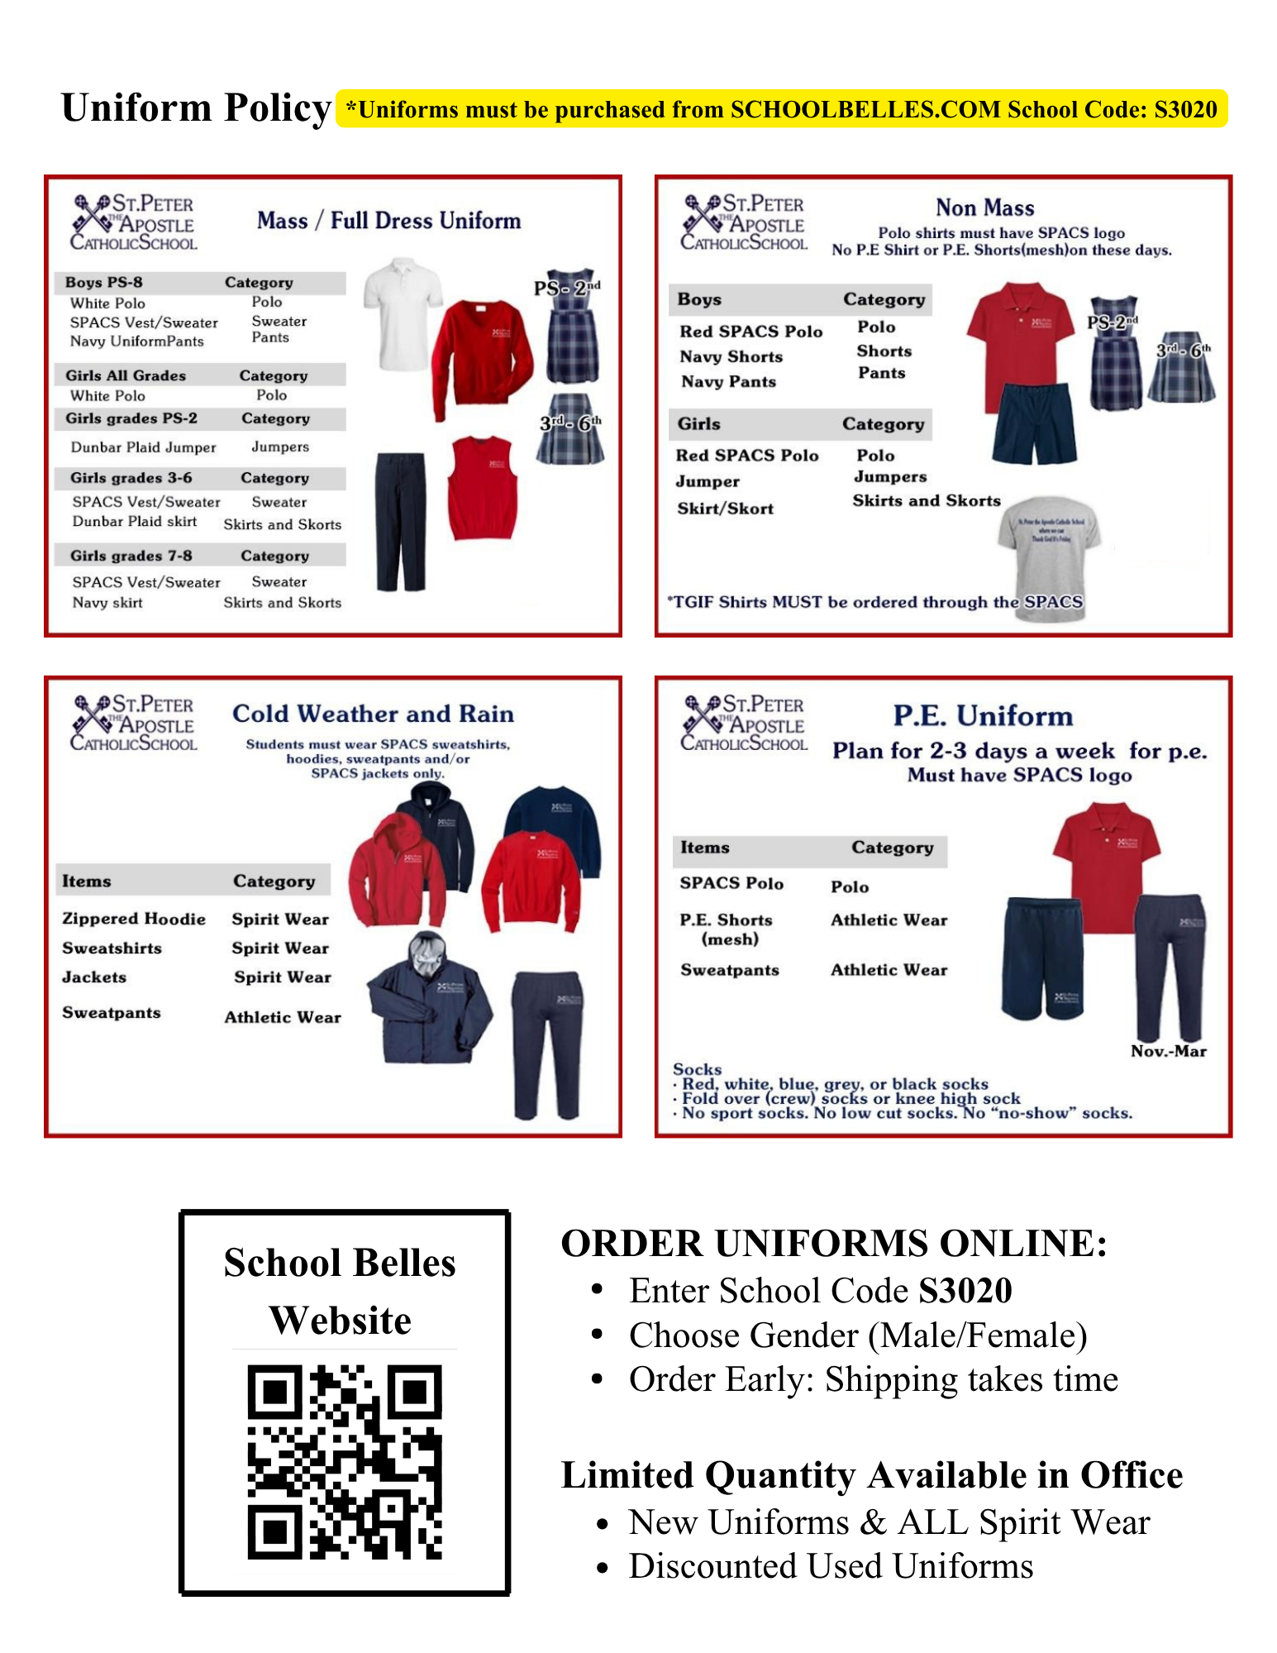
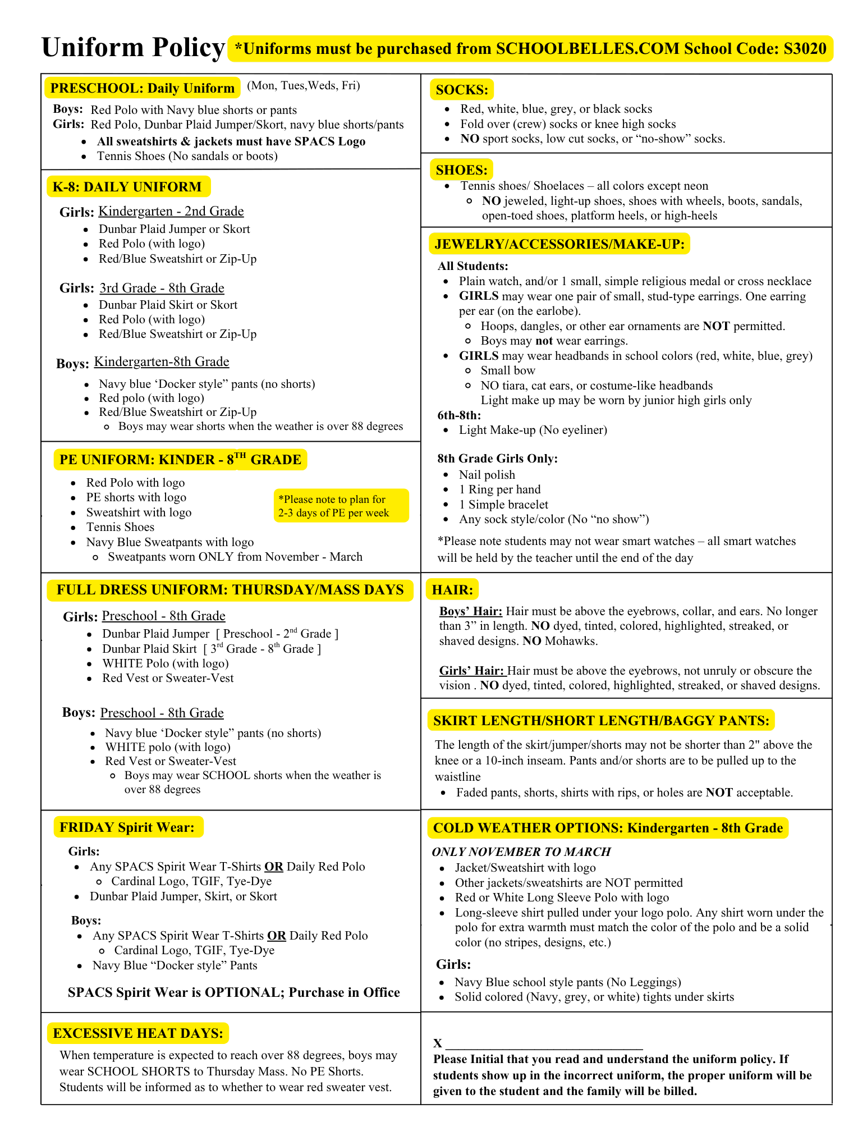

PRESCHOOL HANDBOOK
Preschool Facility License # 3706600760

PROGRAM
A balanced program of child-centered and teacher-directed activities will provide your children with opportunities to enjoy the freedom and responsibility of choice. Through their play, children will explore a nurturing, loving environment and be given the gift of time to experiment, discover, and think. Children are encouraged to celebrate God’s love through prayer, song, and creative activities. Our program provides a solid foundation for children’s cognitive, social, emotional, physical, creative, and spiritual growth. We embrace the ethnic diversity and cultural richness of our community and encourage mutual respect of all individual interests and talents. The preschool is an extension of St. Peter the Apostle Catholic School. Central to our philosophy is the church’s teaching that parents are the primary educators of their children. Our role is to support and work with you in the education of your child.

Our teachers are dedicated to:
- Creating an atmosphere of unconditional acceptance for each of God’s children
- Offering opportunities for children to learn through their own meaningful play
- Recognizing developmental stages and presenting appropriate materials that provide maximum potential for growth
- Teaching fairness, respect, and loving one another
- Providing a safe, nurturing learning environment
- Providing materials and learning experiences that will allow the whole child to develop – not just the body, but also the cognitive, creative, social, and spiritual self.
- Helping children develop language and social skills through play opportunities, while reinforcing their use of words to express feelings and needs
- Encouraging children to explore the world around them; to ask questions, to experiment and to realize the joy of discovery

All of our Preschool teachers are Live Scanned and meet or exceed the early childhood training requirements set by the State Licensing Department. In addition to training and experience, a sincere dedication to work with children in a Catholic environment is the primary requirement for staff selection.

OBSERVATION PERIOD
A trial observation of two (2) weeks is required for all new students entering our program. This will offer our teachers an opportunity to assess the child to determine if our program meets his/her needs.
*If we determine that our program does not meet the child’s needs, a refund of tuition and 50% registration will be refunded.

HOURS
Half Day Program 8:00-12:30
Full Day program 7:30-5:00
Preschool classes begin promptly at 8:15am. Our teachers work hard to create whole group instructional experiences for their students. The latest students may be dropped off to class no later than 10:00am. Please help us by arriving on time so as to not disturb learning in progress. It is our focus to keep the students in their cohorts; however, there are times where classes may be combined. The hours the classrooms will combine will be 7:30-8:00 am and 4:00-5:00 pm as needed.

PROGRAM CHANGES
If families switch program days and times there will be a $50.00 charge assessed. There will be a one time courtesy program change if needed.

ABSENCES
Please contact the Preschool Director if your child will be absent for more than 2-3 days. There are no make-up days or switching days to make up for the absence.

ARRIVAL AND DEPARTURE PROCEDURES
Parents are required to walk the children into the classroom and sign the daily attendance sheet. Use the same procedure when you pick up your child at the end of the session, making sure the teacher sees you leave. A full signature is required when children are signed in or out. Only those people listed on the child’s designated pick-up list will be allowed to pick up the child. Please list all family members and friends that can pick up your child. Any person listed on the designated pick-up list may be asked to show picture identification before the child is released. Please notify the preschool of any changes in pick-up authorization.

LATE PICK-UP FEES
Please call if an emergency delays you. Our afternoon extended care ends promptly at 5:00pm. There will be an additional charge of $5.00 per minute after 5:00pm. We do not have a grace period, so please make sure that you are on time.

HEALTH
Our goal is to maintain a healthy environment for the children and staff. If the school sends home a student that is sick, the student will need to stay home for a minimum of 72 hours to ensure that they are healthy. If you notice that your child is sick, please do not send them to school and keep them home until they are symptom free for at least 24 hours. If you send your child to school sick, this is detrimental to our staff and other students. We need to have everyone healthy so we can stay open. We may need to ask you to keep your child at home for the remainder of the school year if they persistently come to school sick. The following criteria will be used as guidelines for sending a student home.
- A temperature of 100 ⃘ degrees, after being taken once and thirty minutes later with no change downward.
Students should remain home until 24 hours without the use of fever reducing medications (Motrin, Tylenol).
If your child had a fever overnight or in the morning, please DO NOT give him/her Tylenol/Motrin and then SEND THEM TO SCHOOL! If he/she has had a fever prior to the start of school, please keep him/her home to prevent the spread of germs.
- A cold accompanied by sneezing, runny nose, coughing, congestion
- Green drainage or sputum
- Vomiting
- Loose watery stools-Students will be observed after the first two watery stools and sent home after the third. If there are other symptoms present, students will be sent home after the second watery stool. If diarrhea persists on a daily basis, students may return to school with a written statement from their Health Care Provider (HCP) that no viral, bacteriological, or parasitic condition exists.
If a student has a medical condition or food intolerance that causes loose stools, a written note from their HCP is required. Students sent home for loose stools may return to school 24 hours past their last loose stool without the use of medication.
- Contagious diseases not under treatment or a non-specific rash (chicken pox, shingles, scabies, head lice) Student needs to be picked up promptly from school and not return until nit free and have been treated for 24 hrs.
- Impetigo and ringworm are allowed in school if under medical treatment and the sight is covered.
- Any child with a fever accompanied with a rash will be sent home.
- Fever Blisters- students with open blisters or mouth sores should be excluded from school and not return until lesions/blisters are dry.
- Other medical concerns (pneumonia, persistent coughing with copious amounts of thick yellow/green sputum or any other distress noted) will be at the principal discretion.
- The Principal/Preschool Director reserves the right to waive and/or deviate from any of the above recommendations.
*Please keep your child home if they are feeling tired, not acting like themselves or showing any possible signs of flu-like symptoms. Please help us stop the spread of germs.

SCHOOL EMERGENCIES
If your child becomes ill or is injured at school, he/she will be kept comfortable while we contact you to pick him/her up. You will have 1 hour to make arrangements for your child to be picked up or you will be charged a $50 fee for us to watch and monitor your child. Please keep all emergency information up to date. If the illness or injury is serious, and the parents cannot be reached, the school will arrange for the authorized treatment.

BEHAVIOR EXPECTATIONS
We respect your child’s ability to solve many of their own problems if given the time and opportunity. Aggressive or dangerous behavior or biting will not be tolerated. Our staff will respond immediately with parent communication if a child’s behavior places another child in jeopardy. If a child’s behavior continues to disrupt the teaching environment or endanger other children’s safety, the preschool maintains the right to ask a family to withdraw their child.

DISCIPLINE
Children may not be disruptive to our teaching or to the learning, safety, or development or others. As a Catholic school we teach kindness and gentleness.

For the first instance of disruptive behavior:
Teacher will talk to the child about behavior
Child may be asked to choose a different activity

For the second instance of disruptive behavior:
The child will be moved away from the other children for a time out
The child will be asked to make amends for the wrong behavior

For the third instance of disruptive behavior:
The child will be escorted to the Principal’s office
If the child has further difficulty, the parent will be contacted
If the behavior plan fails, the parents will be asked to withdraw the child from the program.

CLOTHING/UNIFORM

See uniform policy below for what preschool students need to wear to school each day. Please make sure all uniform items are purchased through Dennis Uniforms. Tennis shoes are required (no neon or light-up shoes. Parents will be required to bring new shoes, or the child cannot stay if they come to school in sandals or open toe shoes.

Daily Uniform: Monday to Wednesday & Friday | FULL DRESS UNIFORM: THURSDAY/MASS DAYS
· Red Polo with Logo  · Navy blue shorts or pants (for boys)  · Dunbar Plaid Skort or Jumper, navy blue shorts or pants (for girls)  · All sweatshirts and jackets must have SPACS logo  · Tennis Shoes (no sandals, boots, light-up shoes, or crocs) | Girls:  - Dunbar Plaid Jumper  - White polo (logo polo is optional)  - Red pullover sweater with logo (optional- may want for mass when it is cold)  Boys:  - Navy blue ‘Docker style” pants (no shorts)  - White polo w/logo  - Red vest or Red pullover sweater with logo

MASS
Preschool attends Thursday Mass and Holy days of obligation. Drop off hours on Mass days is 8:00 am or after mass at 9:30 am. Due to licensing regulations, you MUST sign in your child in the classroom. You cannot drop off your child as we are walking to Mass, or bring them directly to the church, unless you will be sitting with your child for the entire Mass. You are welcomed to sit with your child and walk them over to preschool and sign them in when all classes return from Mass.

CUBBIES
Each child is assigned a cubby space. Please bring a complete change of clothing (underwear, pants/shorts, socks, shirt, and shoes) in case of a bathroom accident. All belongings must be marked with your child’s name.

POTTY TRAINED
Children in PS-2 are the only students that we will work with parents to help potty train their child. Parents need to supply diapers, wipes, plastic bags, and any other diaper bag supplies. Students in PK-1 that are not completely potty trained by the start of school, will need to pay an additional $150.00 per month for 60-days. If the child is not potty trained by October, the student may not return. In Pre-K2, we will not accept children into our program that are completely potty trained.

ITEMS FROM HOME
We welcome items of interest from home to share, including science and natural materials, books, etc. We ask your assistance in screening the items that come to the school. We do not allow guns, war toys, or other toys of destruction.

MEDICATIONS
Our staff will only administer prescription medication (medicine must be in the original labeled container). A Medication Release Form must accompany each medication. Since medication can often affect the behavior of a child, please let us know if he/she is being treated. We cannot administer over the counter medication.

BIRTHDAYS
Please let your child’s teacher know in advance (about one week) if you would like to bring in a birthday treat. This will allow the teacher time to prepare for your child’s special day and be able to tell you how many goodies are needed. We recommend cookies, muffins, cupcakes, donut holes, fruit, or yogurt. Please do not send in a whole cake. All Birthday celebrations will be served during the morning snack. All treats must be in your child’s classroom by 8:30am on the day of the celebration. Please include plates, napkins, and forks. If you want to distribute birthday party invitations at school, keep in mind that feelings do get hurt. Please send enough invitations for all children in your child’s class. If you are unable to accommodate all of the children, please make other arrangements to distribute the invitations.

LUNCHES/SNACK
Parents are responsible for providing lunch and morning snacks for their child as well as a filled water bottle.. Please pack healthy and nutritious lunches. Do not pack soda or candy. We can microwave lunches. Full day students will need to bring an afternoon snack.

Nap
Full time students need to provide napping supplies weekly.
- Crib sheet
- Small blanket
- Travel-size pillow
- Stuffed animal (optional)
*Children needing a sheet/blanket will be given a school sheet/blanket to use for the day. If your child does not have bedding, a $25 charge per week will be billed for the use of a school sheet/blanket.

STUDENT EVALUATIONS
Preschool students are evaluated on their social-emotional behavior as well as academics. These evaluations are on-going and will occur throughout the year. Formal evaluations are done in the fall for Pre-K and PS-3 students. Parents will be provided with information regarding the evaluation. In the Spring, Pre-K and PS-3 will do another evaluation to help you with ideas and concepts to work with your child at home. In PS-2, we will do informal evaluation to help guide their learning and offer parent support. The focus in PS-2 is their social-emotional behavior as well as learning to interact with their teachers and peers in the classroom setting. At the end of the year, Pre-K students are given a Kindergarten Benchmark to ensure readiness for the upcoming school year.

PARENT CONFERENCES
Parent conferences need to be scheduled with the Preschool Director. Please provide what information that you would like to discuss, so the materials or proper information can be brought to the meeting.

REQUIREMENT TO REPORT SUSPECTED CHILD ABUSE
All preschool teachers and staff are mandated to comply with the child abuse reporting requirements as stated in the Department of Social Services Community Care Licensing, Title 22 Handbook.

PRESCHOOL PARKING
Preschool families need to park in the school or church parking lot and walk the children to the classroom. Each child must be signed in and out daily with a full legal signature. Parking is never permitted in the school car line area or a fine of $25.00 will be assessed for each violation.

Paperwork
All paperwork must be turned in before the child starts school. Immunization record, Birth certificate, Bapitmal certificate, Physicians report, and the preschool registration packet.

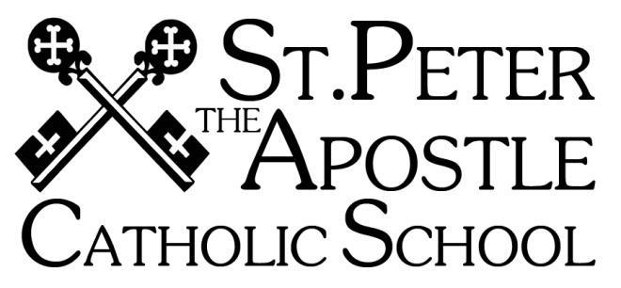
Rights and Responsibilities of Students

I have the right and responsibility to learn in a Catholic atmosphere.
- I am responsible for my own learning, and I allow others to learn.
- I will always do my best.
- I will come to class prepared with necessary books and materials.
- I will do my homework.
- I will arrive on time for school.
- I will be respectful during prayer, liturgy, religious celebrations, and school activities.
I have the right to be respected and to be treated with dignity and the responsibility to treat others in a similar manner.
- I will treat everyone kindly and with respect.
- I will speak to others in an appropriate and polite manner.
- I will listen respectfully when others speak.
- I will respect other people’s space and belongings.
- I will work so that other students can work.
I have the right to be safe and the responsibility to permit others to feel safe.
- I will obey all school and classroom rules.
- I will avoid games that promote violence or that could hurt others.
- I will not bully or tease others.
- I will report any bullying or teasing to a supervising adult.
- I will tell an adult if someone is hurt or doing something dangerous.
- I will listen to the playground supervisor.
- I will use school equipment in a safe and respectful manner.
- I will play safely on the playground equipment and only when it is my turn.
I have the right to learn in a clean environment and the responsibility to do my part in helping to keep our school environment clean.
- I will keep my desk and classroom neat and tidy.
- I will clean up after myself after recess and lunch.
- I will keep the restroom clean.
- I will throw litter in the trash.
- I will cooperate in keeping our school yard clean.

As a member of my Catholic school community, I pledge to: Resolve problems in a peaceful way. Set the example by being a caring and compassionate person. Use kind words, and not to tease others. Never let my words or actions hurt others. Always be part of the solution and encourage others to do the same.

Parent Expectations
- Families attend weekly mass.
- Role modeling to your children especially in kindness, respect, and integrity.
- Give your time, talent and treasure.
- Regular giving to the parish and other Catholic charities.

PARENT CONTRACT
I, ,understand this contract regarding St. Peter The Apostle Parish Rights and Responsibilities.
Family Name: __________________________________ Student’s Name(s): ___________________
________________________ ________________________ ______________________
Parent/Guardian signature: Date:
Student Signature(s): Date:

ATTENDANCE POLICY & PARENT CONTRACT

Absence and Tardiness
Students enter the classroom at 7:50am. Instruction begins at 8:00am. Students arriving after 8:00 am will be marked tardy. If a child is going to be absent, parents are asked to email the teacher before 7:50 a.m. You do not need to call the office. A student who has been absent 18 or more days in a reporting period, and who has not made up the academic work, will not receive a grade in the class or classes missed for that reporting period. A reasonable extension to complete missed academic work may be granted after evaluation of individual circumstances. Parents are urged to keep such requests to a minimum and are encouraged to make appointments during vacation periods or after school hours. Students leaving school before dismissal will be marked a half day absent.

Students arriving after 8:00 am will be marked tardy.
· 1st Trimester – If a student is tardy over 9 times, an email will be sent to the parents. The student may miss out on a fun activity due to chronic tardiness.
· 2nd Trimester - If a student is tardy over 7 times, an email will be sent to the parents. The student may miss out on a fun activity or due to chronic tardiness.
· 3rd Trimester - If a student is tardy over 5 times, an email will be sent to the parents. The student may miss out on a fun activity due to chronic tardiness.
* Students in grades 4-8 may serve a detention for chronic tardiness. Teachers will send an email home prior to the child serving the detention.

Excessive tardiness and school absence disrupts student learning. Students who have over 9 absences and/or tardies in a trimester will be required to meet with the principal. If it persists, the principal may determine that an alternative school placement is necessary or contact local authority.

Absenteeism
Parents need to email the teachers if their child is absent. If a student has an excessive number of absences (18 days), the promotion of the student to the next grade will be in jeopardy. If your child is in Grade 8, they may not receive their diploma or participate in Grad Week. A letter will be sent home to parents once the child has 10 absences. Students that arrive after 9am or leave prior to dismissal at 3:00 will be marked a half day absent. Excessive absenteeism affects the child and the classroom setting.

PARENT CONTRACT
I, ,understand this contract regarding St. Peter The Apostle Parish Catholic School Attendance Policy.

Family Name: ______________________________ Student’s Name(s): ___________________
________________________ ________________________ ______________________

Parent/Guardian signature: Date:

STUDENT / PARENT CONTRACT:

PHONE PRIVILEGE and other ELECTRONIC DEVICES
St. Peter the Apostle Catholic School provides students with technology devices to be used in the classrooms to support our educational efforts. It is the policy of the school that bringing a device to school is not necessary, and students may NOT be in possession of a cell phone during school hours. Therefore, the school recommends first that all cell phones and electronic devices be left at home unless there are extraordinary circumstances. Please carefully review the following guidelines for students to bring devices on school grounds.

- Only students who turn in this contract to the school are allowed to bring cellular/mobile/smart phones to school. Any other electronic device (including tablets, e-readers, game systems, MP3 players, etc...) should not be brought to school without written permission signed by a teacher or the principal. Should a student not have this signed contract on file and bring an electronic device to school, they will lose their opportunity for a warning and have their phone privilege revoked for the remainder of the school year.
- Students may not have electronic devices, including cell/mobile/smart phones, in their possession or on their person at any time during the school day. Students MUST have their phones turned off and submit them to the homeroom teacher at the start of each day, or immediately after the child arrives on campus. Phones should cause no disruption to the learning environment in any way during the school day.
- Phone use is only permitted after the last bell of the day and only in the presence of a supervising teacher/staff member. Students must ask permission to call, text message, or answer any call or text message. Students may call parents or guardians only regarding transportation or other school related issues. Phones may not be used to access information or communicate with others over the internet during school hours.
- Should a student be observed in possession of a phone, using a phone, or a phone rings, or causes disruption during the school day, disciplinary action may include, but ls not limited to: a confiscation of the phone, a suspension of the privilege, behavior consequence(s), detention, and possibly a fine. Additionally, student abuse of this policy will result in the student losing the privilege permanently.
- Our school promotes responsible use of technology, maintaining the integrity of the learning environment is our top priority, so no exceptions will be granted to this policy unless prior written approval from the principal is granted.
Should confiscation occur the phone will only be returned when retrieved by a parent or guardian. St Peter The Apostle Catholic School is not liable for any contract fees that you may incur should the phone be confiscated and not available for use. While in possession of the teacher or the school, its faculty and staff are not responsible for the safety or condition of any electronic device and cannot be held liable for any damage, accidents, or theft.

STUDENT CONTRACT

I, request permission to have a phone on campus. I understand that this privilege may be revoked at any time by the administration for violating the school policy regarding such possession. I have read and understand the school policy for the Phone Privilege. Furthermore, I understand that the school and its employees are In no way responsible for any theft or damage of my phone or electronic device while on school grounds. The school is not obligated to investigate the loss or damage of any phone or electronic device.

Student signature: Date: __________________

PARENT CONTRACT

I, , understand this contract regarding my student's possession of a phone on campus. Furthermore, I understand that the school and its employees are in no way responsible for any theft or damage of my child's phone or electronic device while on school grounds. The school is not obligated to Investigate the loss or damage of a phone or electronic device. Should my student's phone or device be confiscated, I understand that it will only be returned when I or another parent/guardian comes to school to retrieve it.
Parent/Guardian signature: Date:

